Lab 3: Using Google Slides to Create Multimedia Presentations

Introduction
Your activity is to explore operating systems and create a multimedia presentation using Google Slides.

Please note: You will be working on this project for two week

Learning Objectives
- Explore a component of operating systems or software
- Practice using the web to find information and transfer it to the presentation
- Know how to create an online presentation with text, images, audio, and video

Assessment
To get full credit, you will need to:
- Successfully create a Google Slide presentation with 15 slides
- Choose a topic that relates to operating systems
- Accurately describe the topic
- Present the topic in a logic format or flow
- Appropriately style the slides using lists (bullets or numbered)
- Add at least two images
- Add at least one video

Suggested Presentation Structure
At a minimum, you will add 15 slides to your presentation that describe your content. Here is a recommended structure for your presentation:
- Slide 1: Title page
- Slides 2-4: Introduce the topic and broadly describe it
- Slides: 5-7: Discuss feature 1
- Slides: 8-11: Discuss feature 2
- Slides: 12-14: Discuss feature 3
- Slides: 15: Summary

Task 1: Choose your topic
There are many topics to choose from! Choose one from this list, or choose your own and inform your instructor.

- Types of operating systems
  - Embedded
  - Real-time
  - Multi-tasking
  - Single-user
  - Single-tasking
  - Distributed
  - Comparison of single- vs multi-tasking
  - Comparison of single- vs multi-user
- Specific operating systems or a comparison of operating systems
  - Unix and Unix-like operating systems
  - Linux
  - Microsoft Windows
  - macOS
  - Android
  - Mobile operating systems
- Specific components of operating systems
  - Kernel
  - Program execution
  - Interrupts
  - Memory management
  - Virtual Memory
  - Multitasking
  - Disk access and file systems
  - Device drivers
  - User interface
- History of operating systems
- How, where, or why are different operating systems used

Task 2: Create your Google Slide presentation
This section describes how to create a new presentation.

- Navigate to https://drive.google.com
- Log into your Google account when prompted
  - If you do not have a Google Account, sign up for one using any email address
(you do not need a Gmail address)
  - For help, see Help Creating a Google Account
- Once logged in: Click New ➜ Google Slides ➜ Blank Presentation
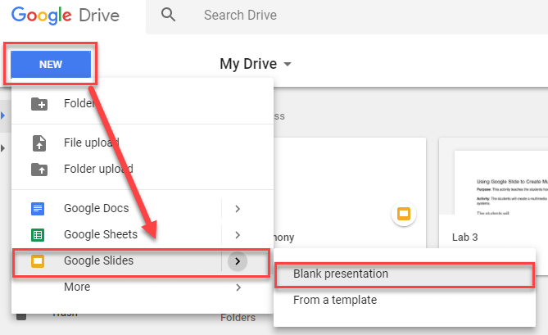
- Give your presentation a title resembling your topic (make the title self-descriptive of the topic)
  - Do not call it something like: My presentation, Untitled presentation, etc.
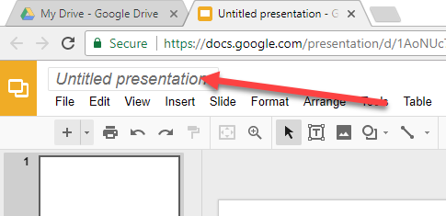
- Choose one of the built-in themes
  - If you closed the Themes panel, you can open it again by: Slide ➜ Change Theme
- Give your presentation a title and subtitle that correspond to your topic

Additional detail:
- The content section will have at least six slides: Two slides for each feature you describe. You can add additional slides to describe the technology in greater details.
- One slide must include an embedded YouTube video

Task 3: Add Your Content
- Add new slide
  - Click on + button or: Slide ➜ New slide
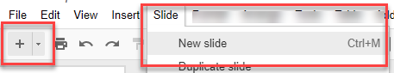
  - The default slide layout is a title with text. If you want a two-column (one column for text and one column for an image), choose it from the layout menu: Layout ➜ Title and two columns
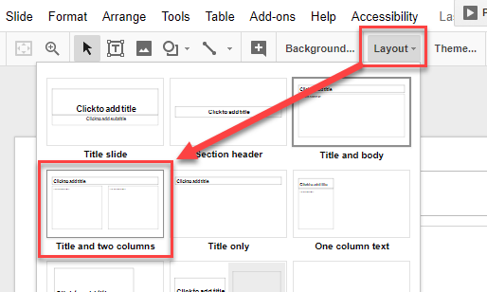
- On slide two, use the default layout, (Title and body). Add 4-5 bullet points describing the technology.
- On slide three, change the layout to Title and two columns.
  - In one column, add three main points about the technology
  - In the other column, add an image that visually represents the technology
- Create slides two slides for the content describing a feature of the technology in more detail
  - Add detail describing a feature about the technology
  - Use the layouts of your choice.
  - Use images to help visually describe the technology

Adding Images
There are multiple ways to add images

Option 1: Insert method
- Open the slide you where you want the image
- Insert ➜ Image
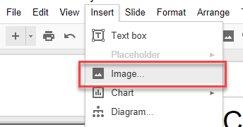
- Upload an image, use the direct image URL, or choose Search
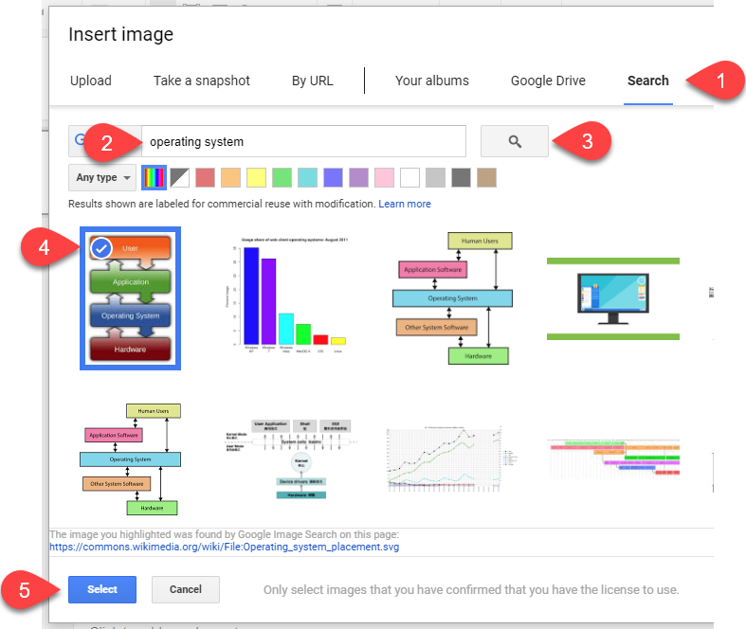

Option 2: Copy/paste method
- Go to https://images.google.com/ and search for an image relating to your technology
- Right-click on the image and choose copy image
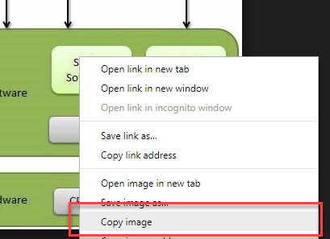
- Open the slide you where you want the image
- Press Ctrl+V or right-click and select Paste
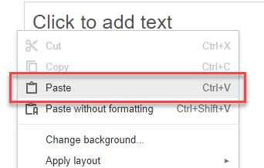

Embedding Videos
You need the embed code add video to a Google Slide presentation. Thankfully, Google Slides does this for you!

- Find the video on YouTube
- Copy the URL
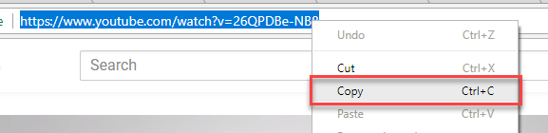
- Insert the video: Insert ➜ Video
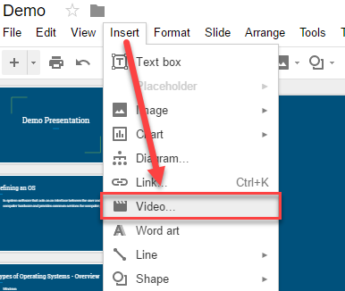
- Select By URL
- Paste the YouTube URL
- Press the Select button
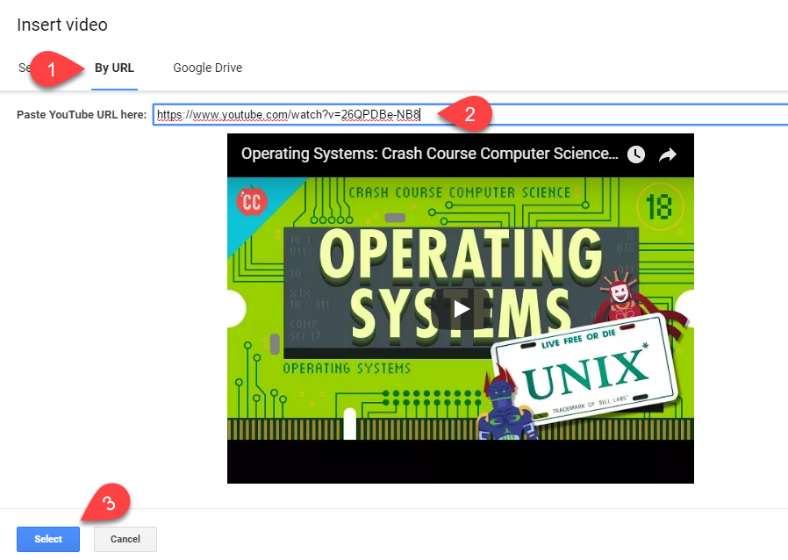
- The video might have black space the top and bottom. Just ignore it.
- Click the Present button to test the video.
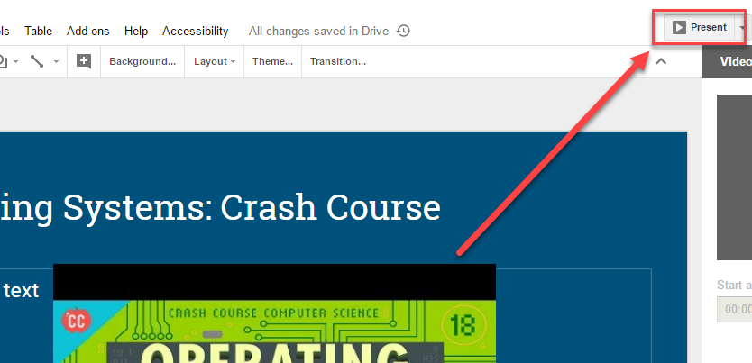
- It should look as expected


Task 5: Submitting Your Project
Before you can submit your project through URL in Moodle, you will need to share it.

- Click on the blue Share button in the upper-right corner or the window
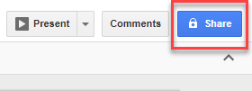
- Click on Get shareable link
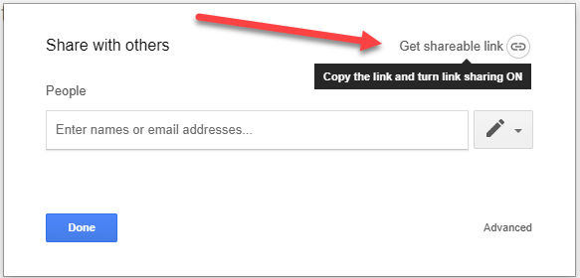
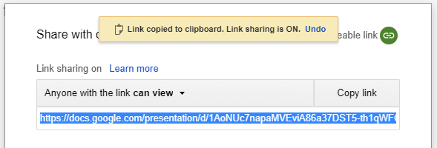
- Change Anyone with the link can view to can comment
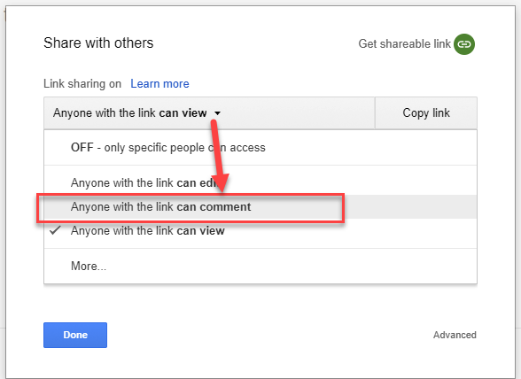
- Press the Copy link button. Note the Link copied to clipboard message when you press the button. Once copied, then press Done.
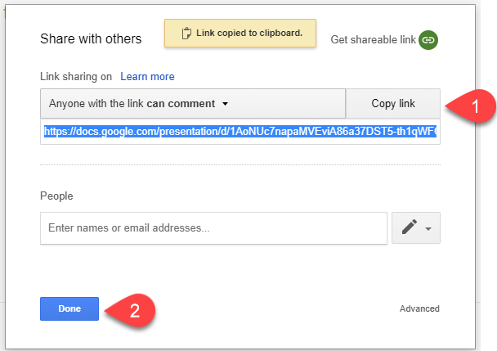
- Send the link to your instructor
  - Enter the URL in the lab 3 submission box -OR- email your link to your instructor

Task 6: Embed in your Google Site
Do you have a portfolio for your ICT work in Google Sites? If you do, please complete this task.

This task is to embed the presentation in a Google Slide

- Open up your Google Site. You can find your site by going to https://sites.google.com/new
- Click Pages ➜ Add page
- Give you page a name: Operating Systems Presentation
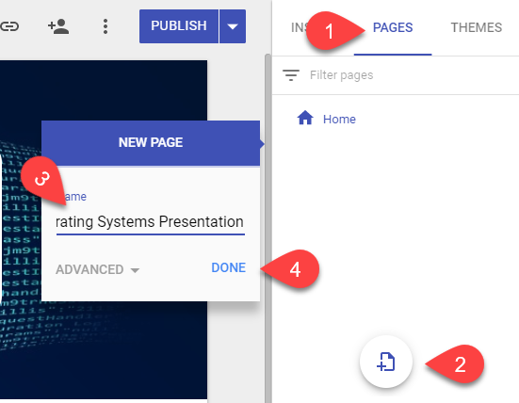
- Once the new page, click Insert ➜ From Drive
- Find your presentation
- Click Insert
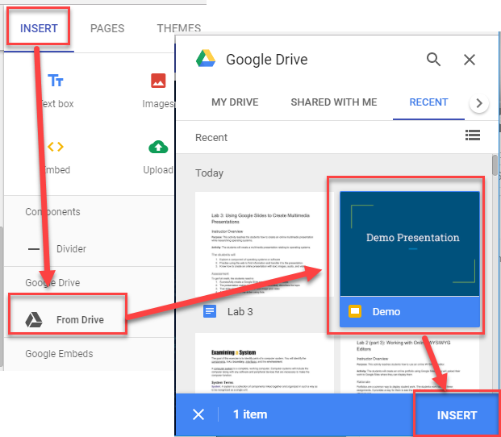
- Resize your presentation as needed
- Go to your home page. Add a link to the presentation page
  - Page ➜ Home
  - Add a new entry in the list, called: Operating System Presentation
  - Highlight the text
  - Click the Link button
  - Select the page
  - Press Apply
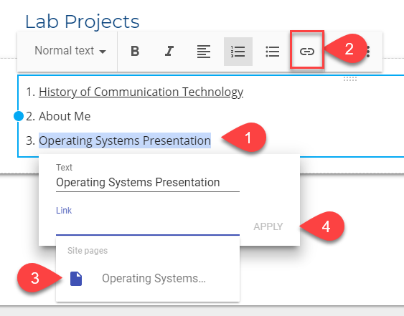
- Click the Publish button so the changes display on your web page
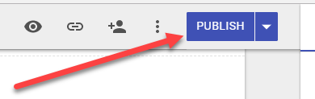
- View your site to see your embedded presentation
